4. Hexagonal Cell Structure &amp; Capacity Planning Simulation

AIM:
To simulate a hexagonal cellular network structure and analyze its coverage, frequency reuse, and capacity performance by calculating cell radius, coverage area, user distribution, and the effect of cluster size on overall network capacity.

TOOLS REQUIRED:
- MATLAB
- Communications Toolbox
- Signal Processing Toolbox
- Laptop/PC

THEORY:

• Hexagonal Cell Structure:
Cellular networks commonly use a hexagonal geometry to model coverage regions. The hexagon shape is preferred because it provides uniform coverage over a plane without gaps or overlaps and simplifies frequency planning.
○ Cell Area:
The area of a single hexagonal cell with radius R is given by:
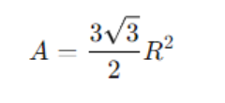
where R is the cell radius.
• Frequency Reuse:
To increase spectrum efficiency, cellular networks apply the concept of frequency reuse, where the same frequency channels are allocated to cells that are sufficiently far apart to avoid interference.
The cluster size (K) represents the number of cells in a group using unique frequencies. Larger K reduces interference but decreases capacity.

• Capacity Planning:
Capacity planning determines how many users or channels a cellular network can support.
○ Channels per Cell:

A smaller cluster size increases channels per cell, thus improving system capacity.

PROCEDURE:

- Set the simulation parameters in MATLAB, including cell radius, number of tiers, bandwidth, spectral efficiency, and cluster size (K).
- Generate the hexagonal cell centers and plot the 7-cell hexagonal structure using the given radius.
- Apply frequency reuse by assigning colors to cells based on the reuse factor K.
- Randomly distribute users within the coverage region and assign each user to the nearest cell.
- Calculate coverage area, bandwidth per cell, capacity per cell, and users per cell based on simulation outputs.
- Plot the user distribution and capacity variation for different cluster sizes.
- Tabulate and record the results obtained from the simulation.

CODE:

clear; clc; close all;

%% PARAMETERS
N_RB = 20; % total resource blocks
N_users = 5; % number of users

%% ------------------ Equal Allocation ------------------
base = floor(N_RB / N_users);
rem = mod(N_RB, N_users);
alloc_equal = zeros(1,N_RB);
idx = 1;
for u=1:N_users
take = base + (u<=rem);
alloc_equal(idx:idx+take-1) = u;
idx = idx + take;
end

%% ------------------ Round-Robin Allocation ------------------
alloc_rr = zeros(1,N_RB);
for rb = 1:N_RB
alloc_rr(rb) = mod(rb-1, N_users) + 1;
end

%% ------------------ PLOT ------------------
figure;

subplot(2,1,1);
imagesc(alloc_equal);
colormap(parula(N_users));
colorbar('Ticks',1:N_users,'TickLabels',{'U1','U2','U3'});
title('Equal RB Allocation');
xlabel('Resource Block Index'); ylabel('Time Slot');

subplot(2,1,2);
imagesc(alloc_rr);
colormap(parula(N_users));
colorbar('Ticks',1:N_users,'TickLabels',{'U1','U2','U3'});
title('Round-Robin RB Allocation');
xlabel('Resource Block Index'); ylabel('Time Slot');

%% ------------------ DISPLAY ------------------
disp('Equal Allocation:');
disp(alloc_equal);

disp('Round-Robin Allocation:');
disp(alloc_rr);

OUTPUT:
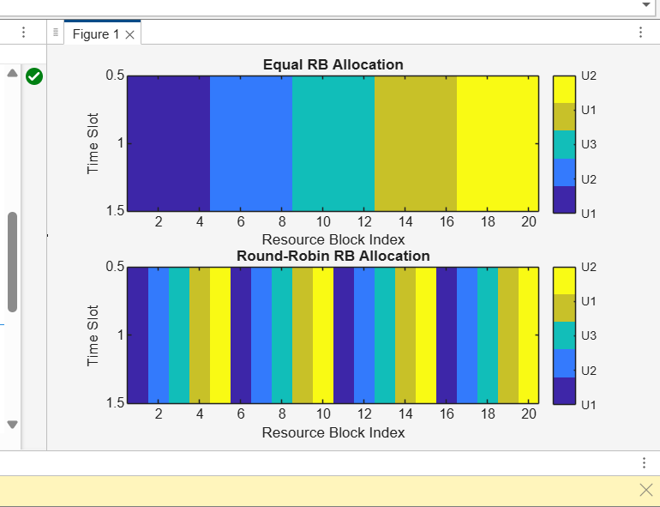
RESULT:
Hexagonal cells provide efficient coverage with minimal gaps, and frequency reuse improves network capacity. Simulation of user distribution and cluster layouts highlights the need for capacity planning and load balancing.

